**GUÍA DE INGLÉS**

|  |  |  |
| --- | --- | --- |
| Name: | Grade: 5°A | Date: semana N° 24 |
| **¿QUÉ APRENDEREMOS?** | | |
| **Objetivo (s):** OA5 – OA14 | | |
| **Contenidos:** Rutinas diarias en inglés. | | |
| **Objetivo de la semana:** Comprender e identificar vocabulario relacionado a las rutinas diarias en inglés. | | |
| **Habilidad:** Identifican léxico relevante aprendido en inglés. | | |

ff

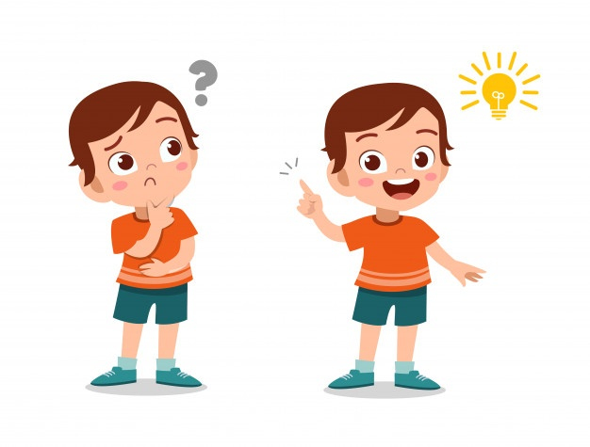

**¿COMO VOY?**

**¿QUE RECUERDO DE LO APRENDIDO HASTA AHORA?**

**I Read the text about this daily routine and then follow the instructions. (Lee el texto sobre las rutinas diarias y luego, sigue las instrucciones.)**

***My daily routine.***

Now that we are with this pandemic, I am in my house all day but anyway I have to do many things… let me tell you. I wake up at 7.30 o’clock but I get up at 8 o’clock, then I have a shower and I get dressed. My mother prepares the breakfast and then I have my online classes until 12 o’clock. Then I can watch Tv for an hour. My mother cooks the lunch, she prepares the food in the cooker. Then we have lunch and we talk for a while. My father washes the dishes and my brother does his homework while my mother works on the computer. Then I chat with my friends by text. My sister prepares the dinner. After that, we go to the bathroom, we brush our teeth and we go to bed.



**I CHOOSE the correct answer for each question about the text. (ELIGE la respuesta correcta para cada pregunta sobre el texto.)**

1.- What is he describing?

a) The school’s routine

b) The house’s routine

c) The vacation’s routine

2.- What time does he get up?

a) At 8 o´clock.

b) At 6:30.

c) At 7 o’clock.

3.- What does he do after breakfast?

a) He chats with friends.

b) He watches TV.

c) He has online classes.

4.- What time does he get online classes?

a) Until 12 o´clock.

b) Until 12:30.

c) Until 11 o´clock.

5.- What does the father do after lunch?

a) He watches TV.

b) He takes a nap.

c) He washes the dishes.

**II MAKE A LIST about the daily routines mentioned in the text.There is a space for each one (Haz una lista sobre las rutinas diarias mencionadas en el texto. Hay un espacio para cada una.)**

1.- ___________________________.

2.- ___________________________.

3.- ___________________________.

4.- ___________________________.

5.-____________________________.

6.- ___________________________.

7.-____________________________.

8.- ___________________________.

9.- ___________________________.

10.- __________________________.

11.- __________________________.

12.- __________________________.

13.- __________________________.

14.- __________________________.

15.- __________________________.

16.- __________________________.

17.- __________________________.

18.- ___________________________.

*Enviar foto de la guia desarrollada al whatsapp del curso y archivar en cuaderno de la asignatura.



**YOU DID IT EXCELLENT!**